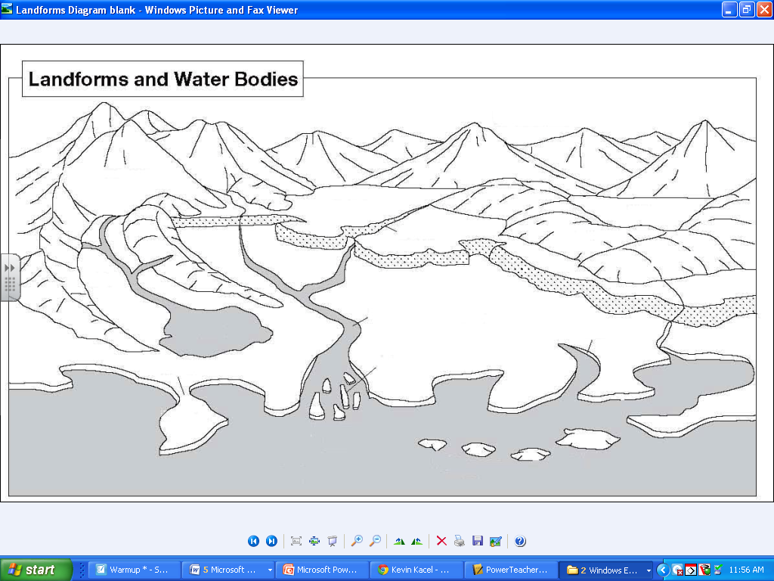

Label each of the following landforms. Once labeled, color each landform with the color listed below.

**Blue** **Green**  **Brown**

River Gulf Plains Delta Canyon

Lake Fjord Peninsula Islands Mountains

Sea/Ocean Hills

Strait Isthmus