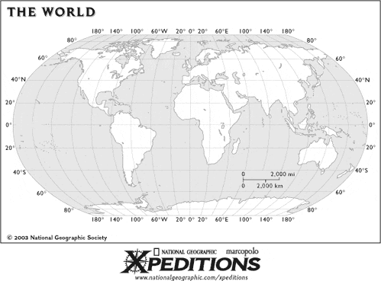
Directions: Label all of the continents and oceans of the world on the map above, and then color each continent a different color.
Africa | Antarctica | Arctic Ocean
Asia | Atlantic Ocean | Australia
Europe | Indian Ocean | North America
Pacific Ocean | South America
Use this map to study for your Daily Map Quizzes.

