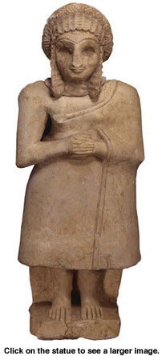

From the earliest times in ancient Mesopotamia, women who came from a sector of society that could afford to have statues made placed their likenesses in temple shrines. This was done so that their images would stand in constant prayer while they continued to go about their daily chores. This female worshipper statue wears a standard fashion of the time, a simple draped dress with her right shoulder bare and hair done up in elaborate braided coils.
The Mesopotamian woman's role was strictly defined. She was the daughter of her father or the wife of her husband. Women rarely acted as individuals outside the context of their families. Those who did so were usually royalty or the wives of men who had power and status.
Most girls were trained from childhood for the traditional roles of wife, mother, and housekeeper. They learned how to grind grain, how to cook and make beverages, especially beer, and how to spin and weave cloth for clothing. If a woman worked outside of her home, her job usually grew out of her household tasks. She might sell the beer she brewed, or even become a tavern keeper. Childbearing and childcare roles led women to become midwives and also to create medicines that prevented pregnancy or produced abortions.
Soon after puberty, a young girl was considered ready for marriage. Marriages were arranged by the families of the future bride and groom. Ceremonies have been described where the future husband poured perfume on the head of the bride. He also gave her family money and other presents. Once a woman was engaged, she was considered part of her fiancé's family. If her husband-to-be died before the wedding, she was then married to one of his brothers or another male relative.

